**Azure ML Ops**

Import Git repo

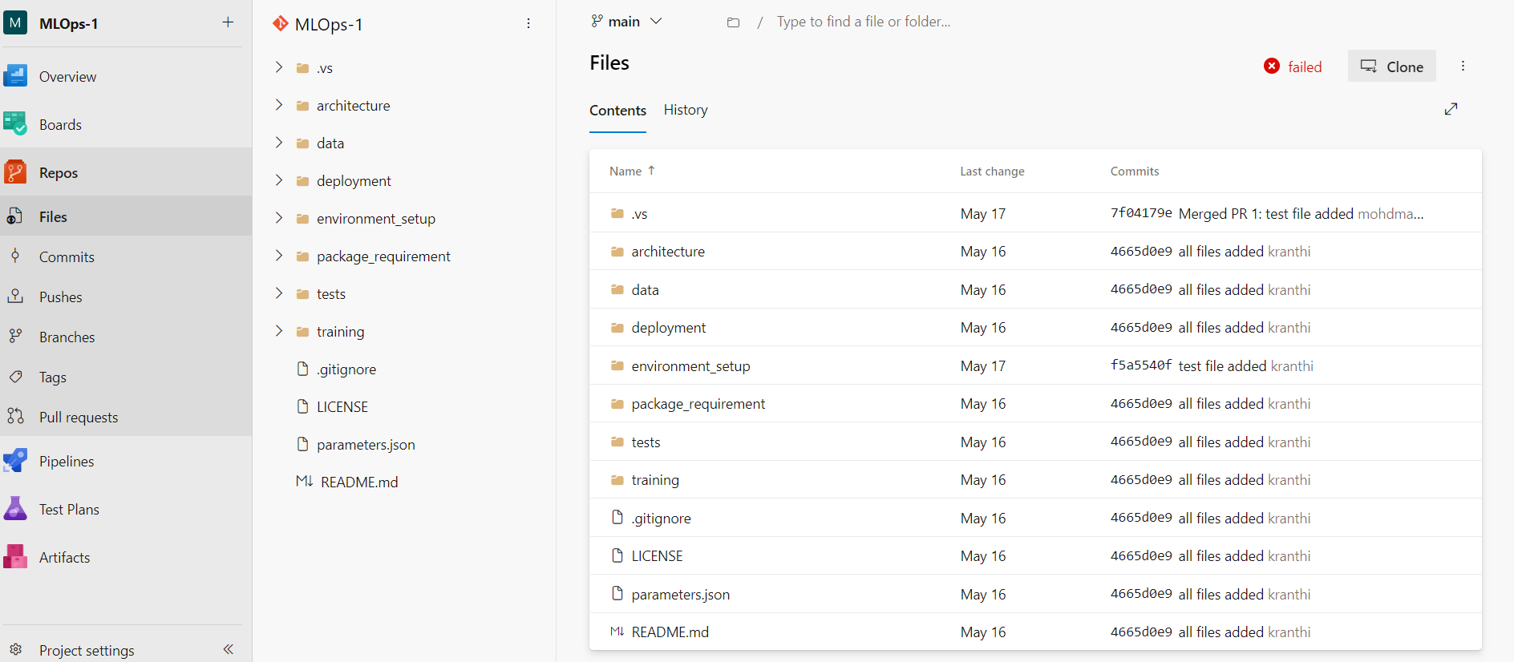

Create Service Connections to Azure Machine Learning

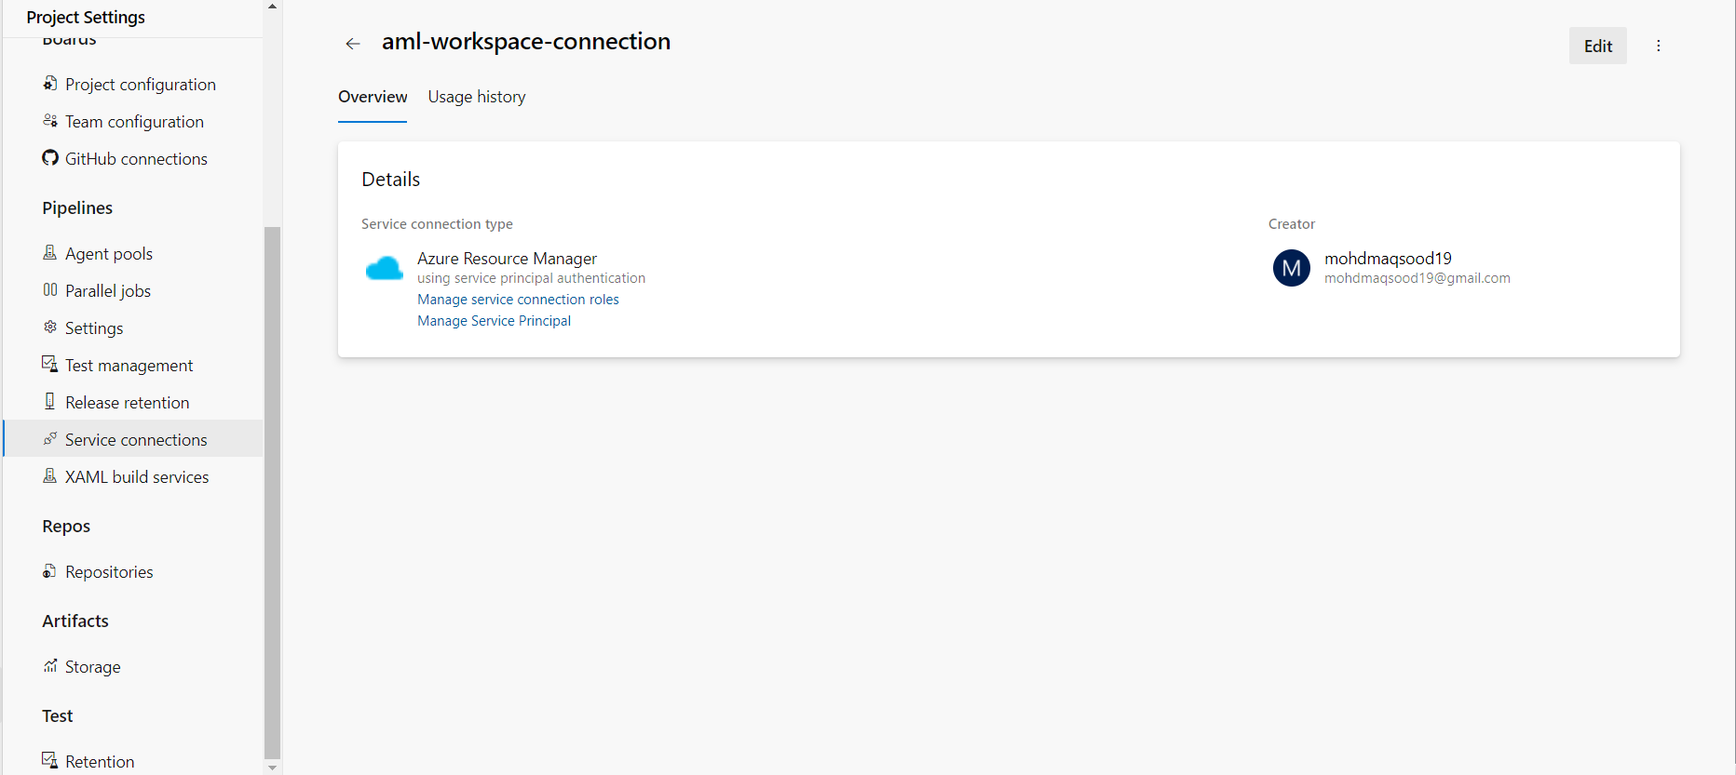

Create Self hosted agent

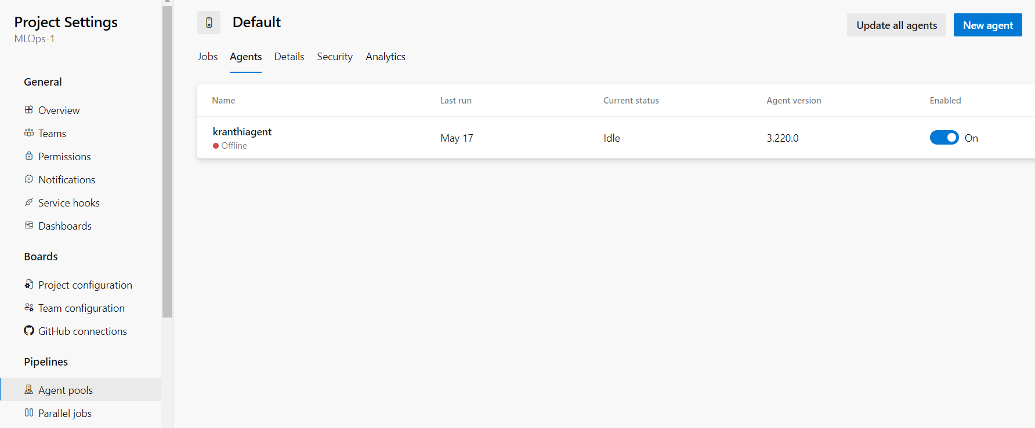

CI Pipeline

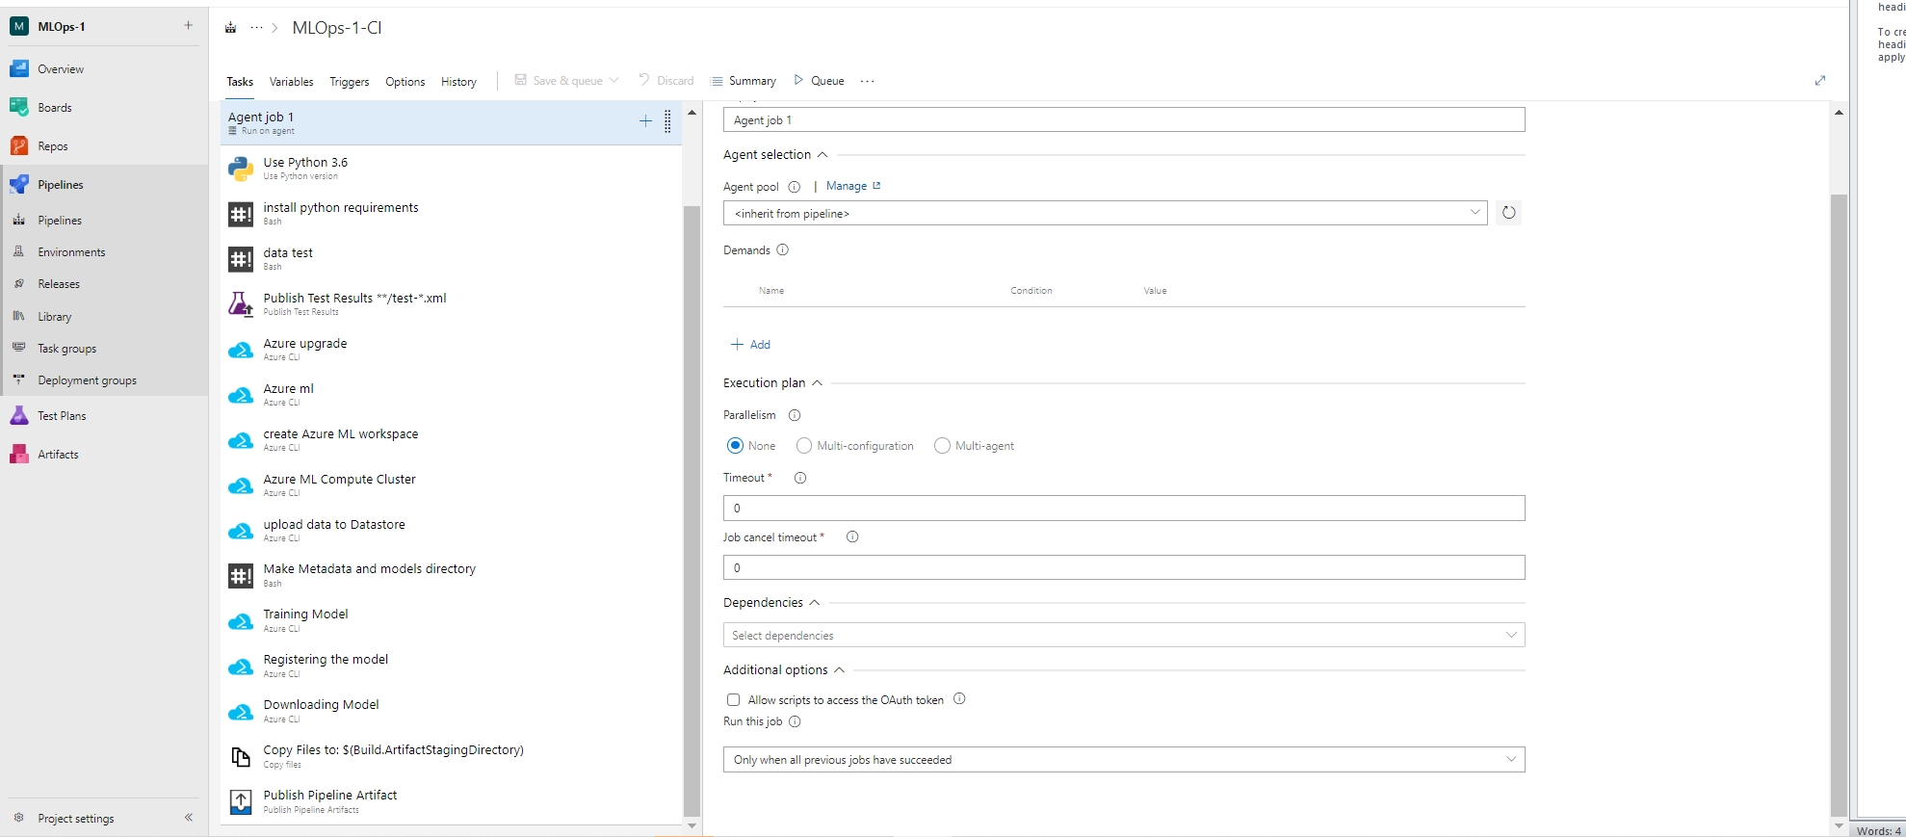

1. Use Python 3.6

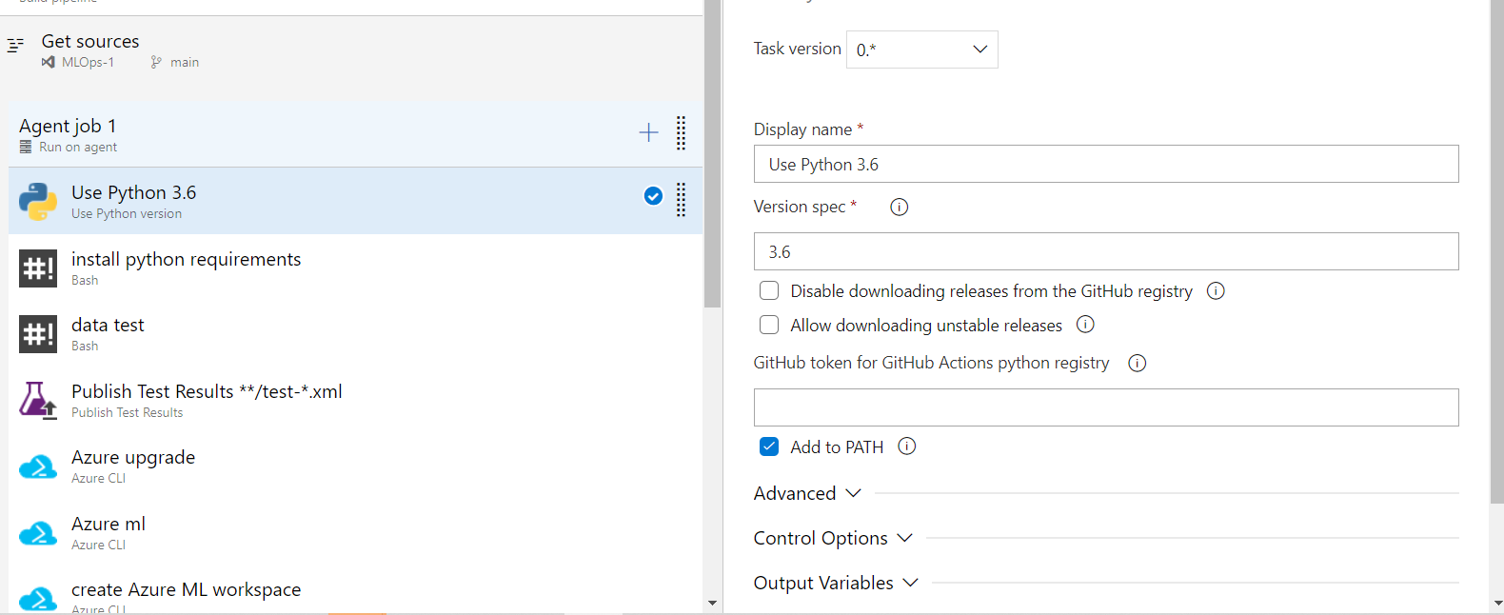

1. install python requirements

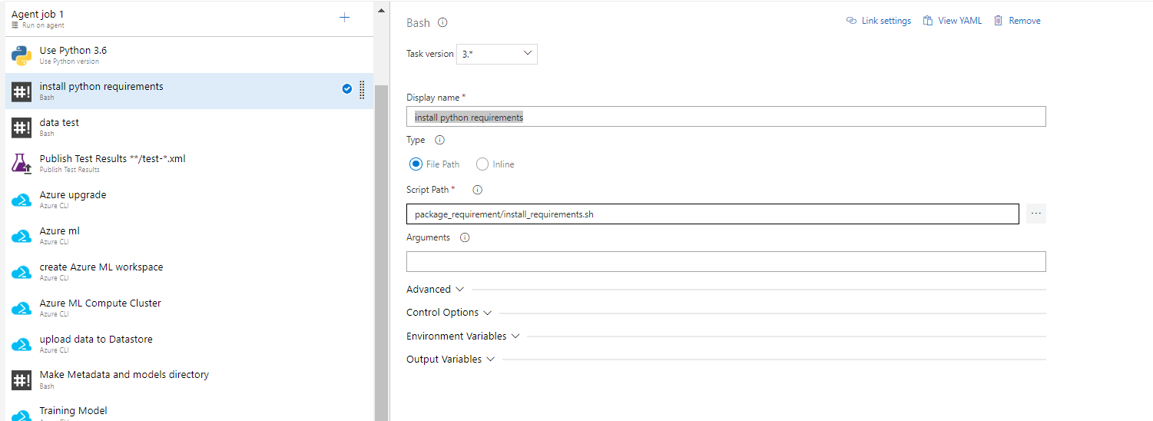

1. data test

cmd : pytest training/train_test.py --doctest-modules --junitxml=junit/test-results.xml --cov=data_test --cov-report=xml --cov-report=html

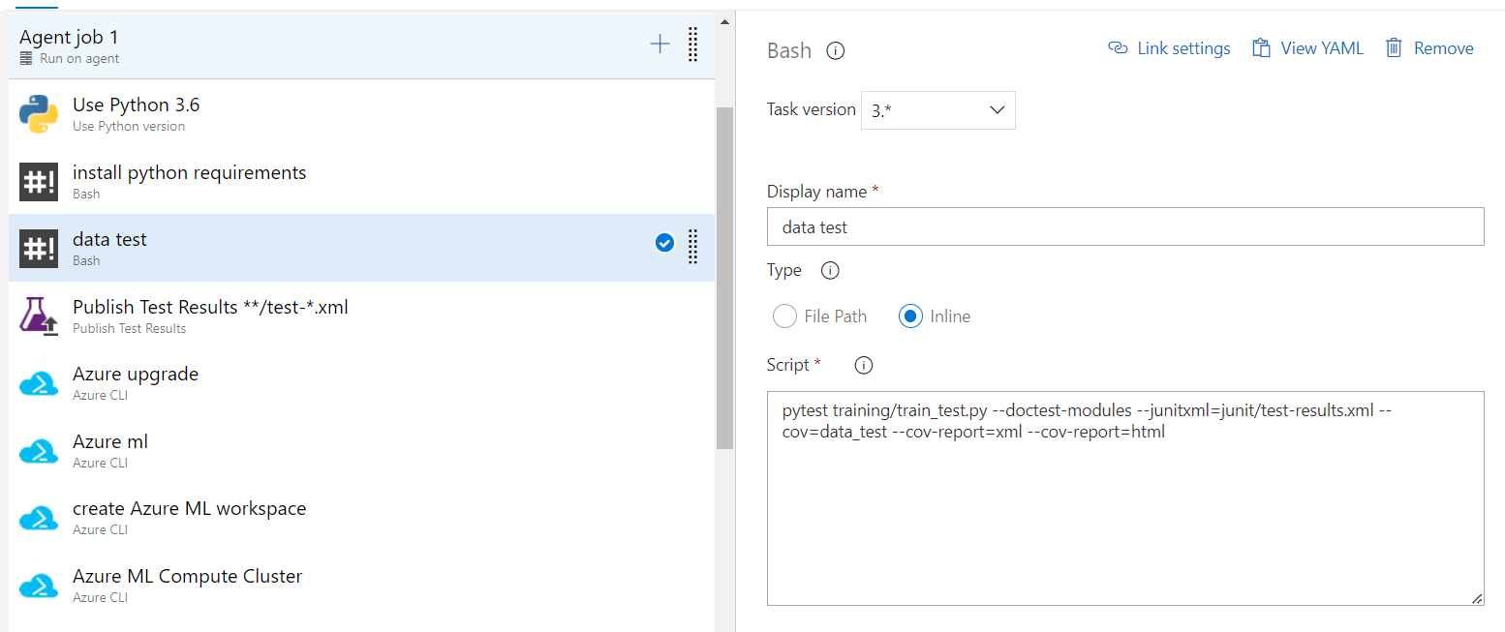

1. Publish Test Results **/test-*.xml

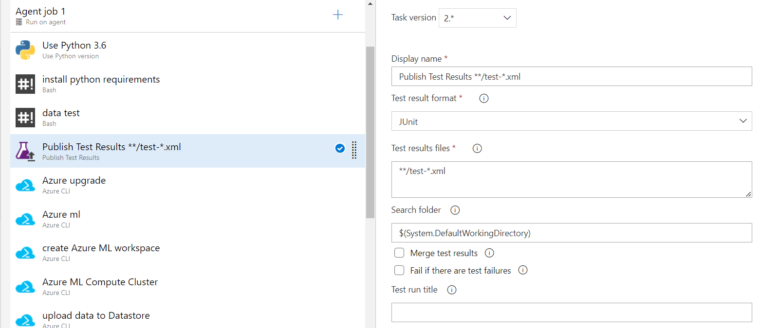

1. Azure upgrade

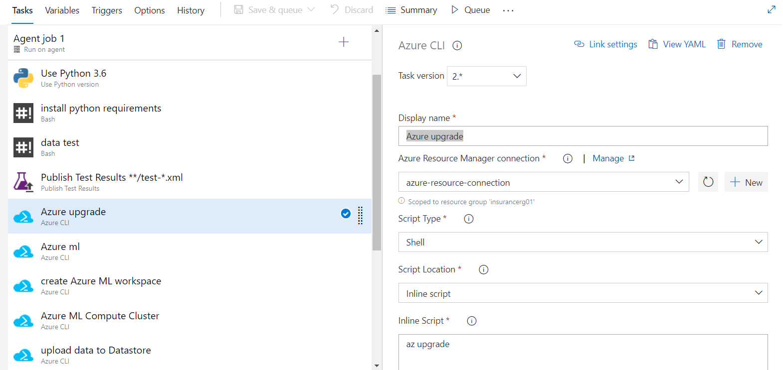

1. Azure ml

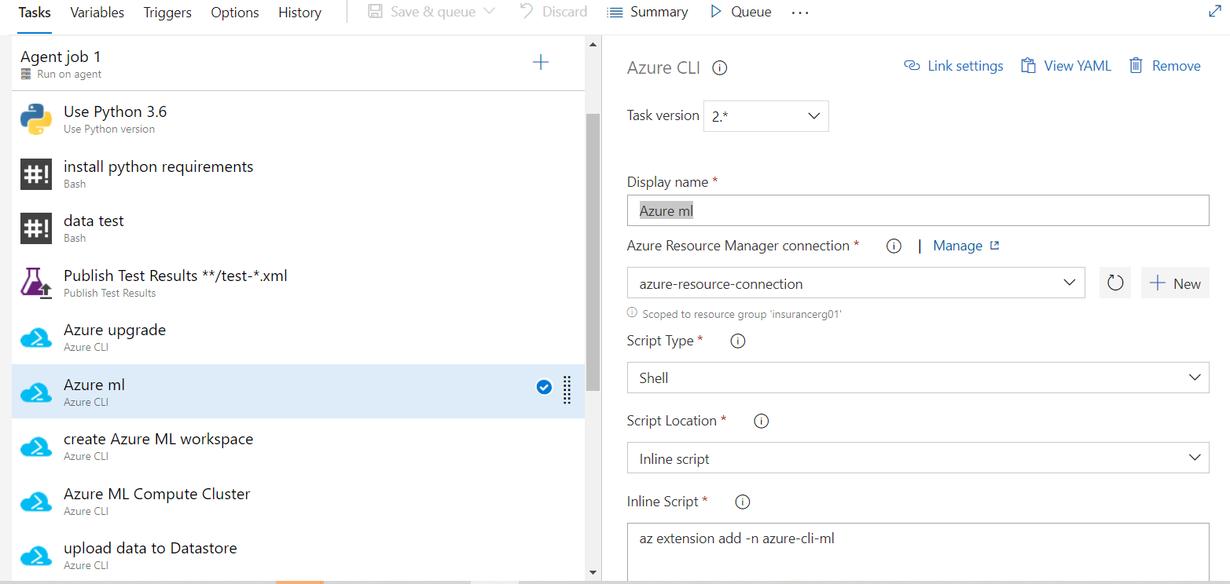

1. create Azure ML workspace

cmd : az ml workspace create -g $(azureml.resourceGroup) -w $(azureml.workspaceName) -l $(azureml.location) --exist-ok --yes

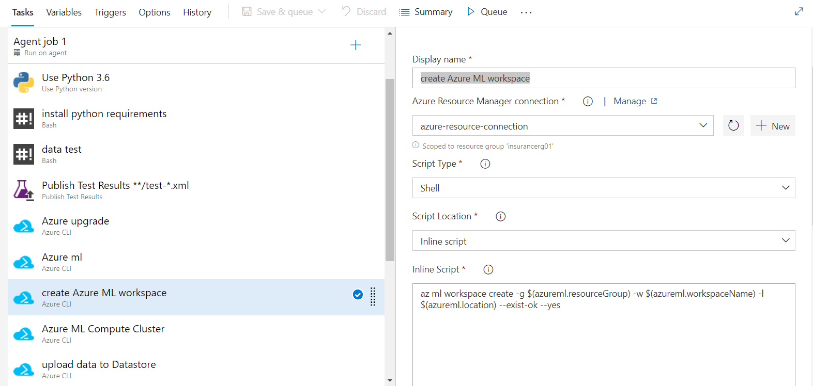

1. Azure ML Compute Cluster

Cmd : az ml computetarget create amlcompute -g $(azureml.resourceGroup) -w $(azureml.workspaceName) -n $(amlcompute.clusterName) -s $(amlcompute.vmSize) --min-nodes $(amlcompute.minNodes) --max-nodes $(amlcompute.maxNodes) --idle-seconds-before-scaledown $(amlcompute.idleSecondsBeforeScaledown)

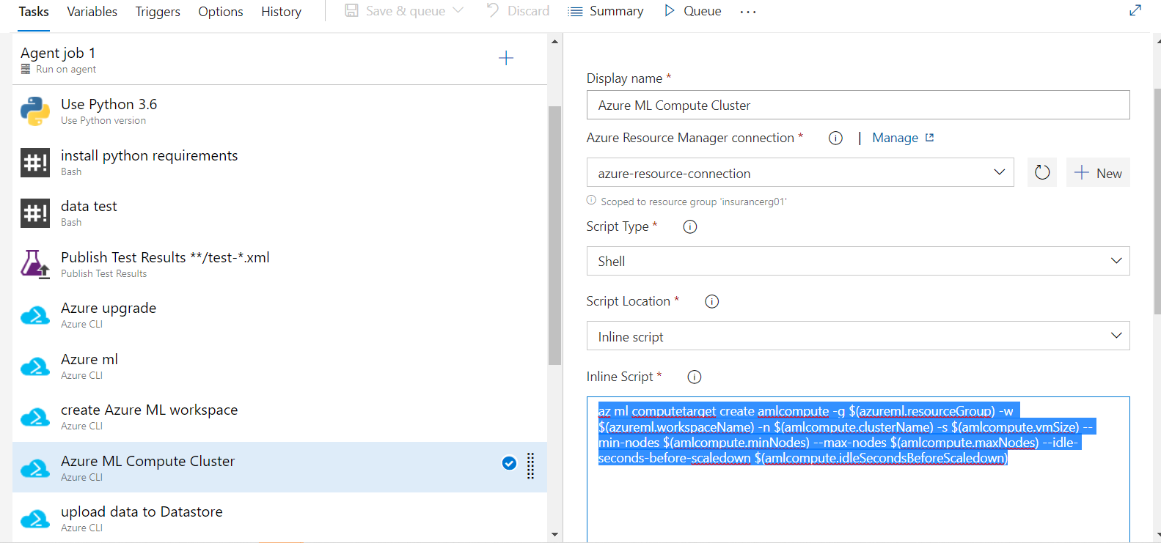

1. upload data to Datastore

cmd : az ml datastore upload -w $(azureml.workspaceName) -g $(azureml.resourceGroup) -n $(az ml datastore show-default -w $(azureml.workspaceName) -g $(azureml.resourceGroup) --query name -o tsv) -p data -u insurance --overwrite true

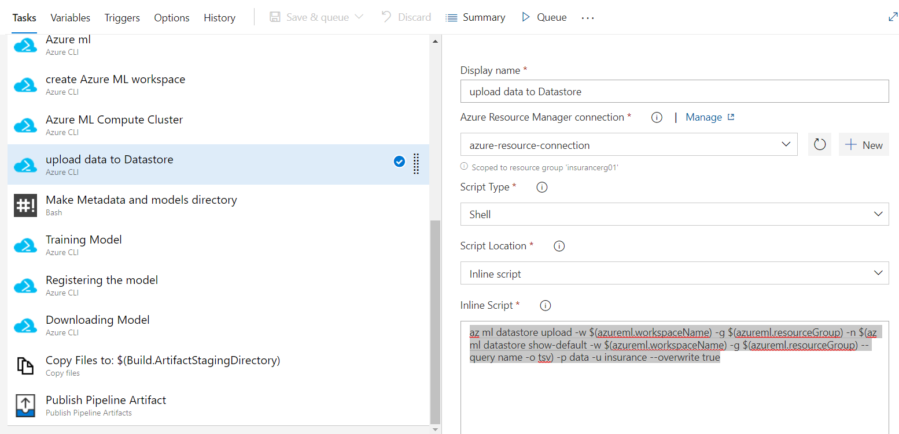

1. Make Metadata and models directory

Cmd : mkdir metadata && mkdir models

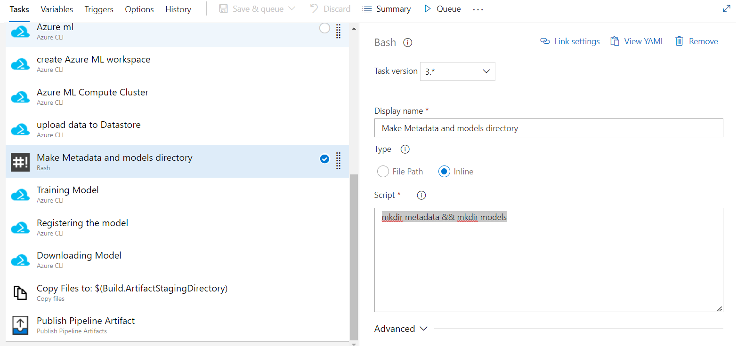

1. Training Model

Cmd : az ml run submit-script -g $(azureml.resourceGroup) -w $(azureml.workspaceName) -e $(experiment.name) --ct $(amlcompute.clusterName) -d conda_dependencies.yml -c train_insurance -t ../metadata/run.json train_aml.py

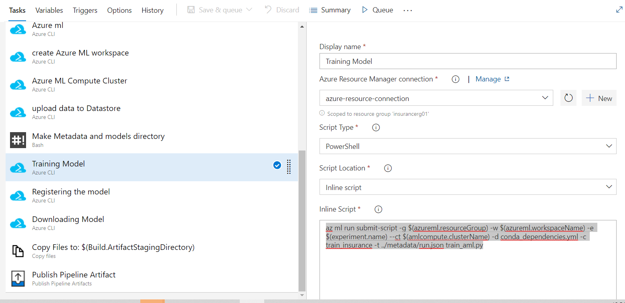

1. Registering the model

Cmd : az ml model register -g $(azureml.resourceGroup) -w $(azureml.workspaceName) -n $(model.name) -f metadata/run.json --asset-path outputs/models/insurance_model.pkl -d "Classification" --tag "data"="insurance" --tag "model"="classification" --model-framework ScikitLearn -t metadata/model.json

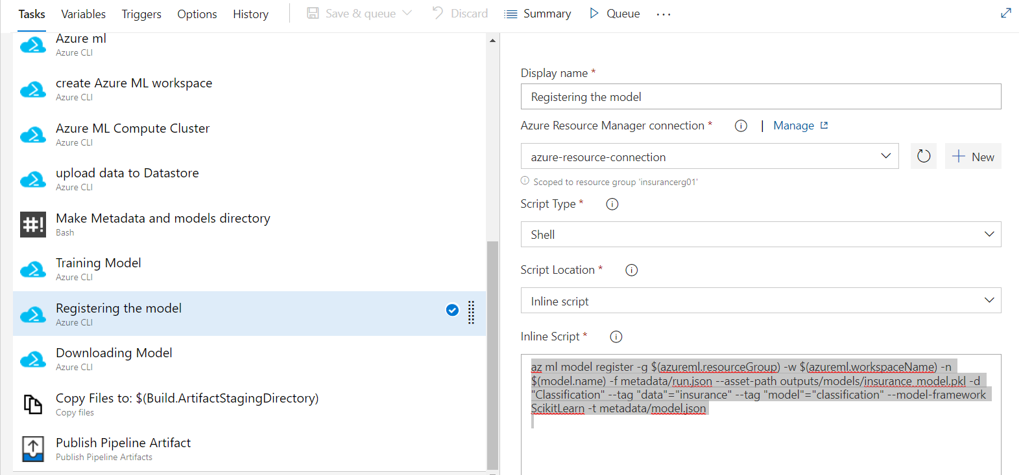

1. Downloading Model

Cmd : az ml model download --name insurance_model --version 5 --resource-group insurancerg01 --workspace-name insurancews01 -t ./models –overwrite

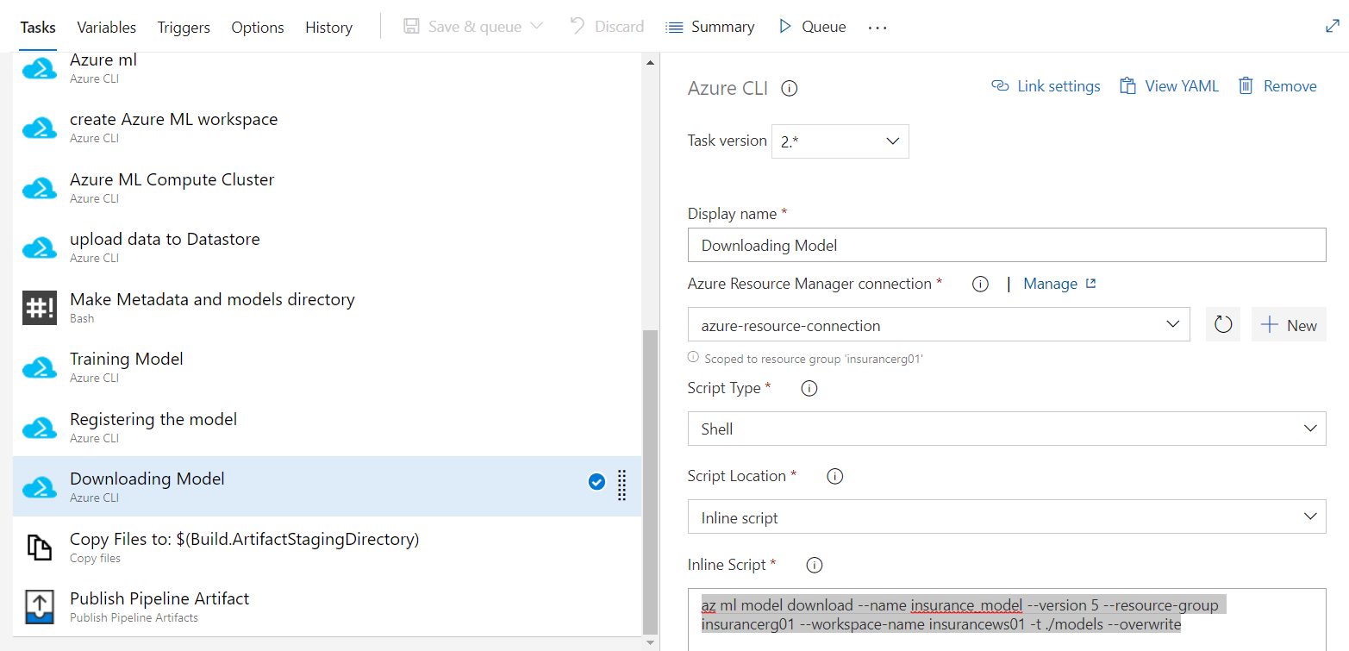

1. Copy Files to: $(Build.ArtifactStagingDirectory)

Data : **/metadata/*

**/models/*

**/deployment/*

**/tests/integration/*

**/package_requirement/*

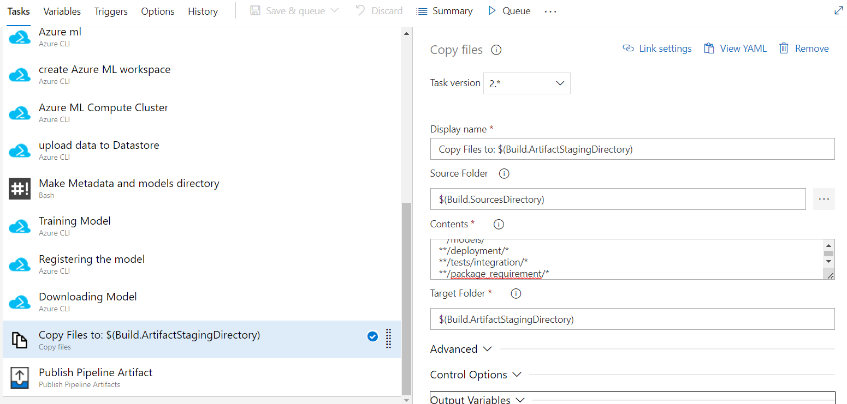

1. Publish Pipeline Artifact

